Ansible

**Aim**: - Install and configure Ansible controller and hostnode using on azure portal.

**Install and configure Ansible controller and hostnode using on azure portal.**

Create VMs ansible-controller and host-node1 on azure portal:

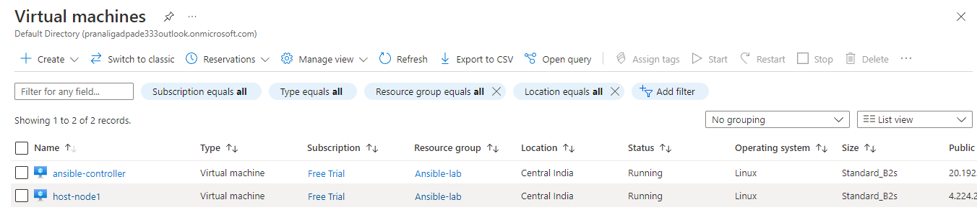

Sudo privilege to admin01 user using the following command:

#vi /etc/sudoers



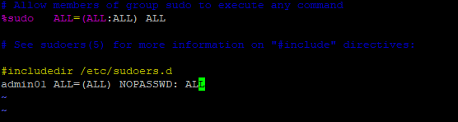

To enabled admin01 Password Authentication by using the following command:

#vi /etc/ssh/sshd_config

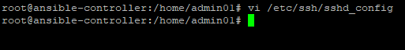



To restart the ssh service by using the following command:

#systemctl restart sshd

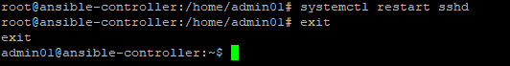

To install ansible on Ubuntu ansible-controller by using the following commands:

To configure the PPA on system and install Ansible run these commands:

$sudo apt update

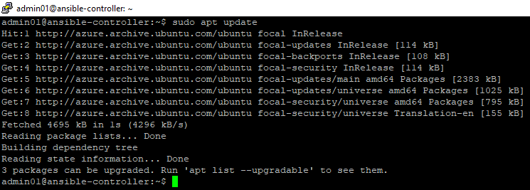

$sudo apt install software-properties-common

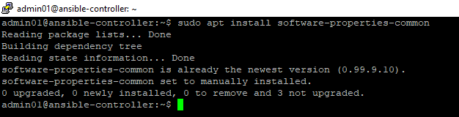

$sudo add-apt-repository --yes --update ppa:ansible/ansible

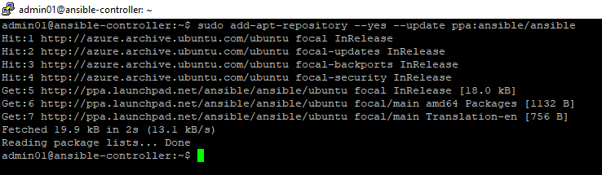

$sudo apt install ansible

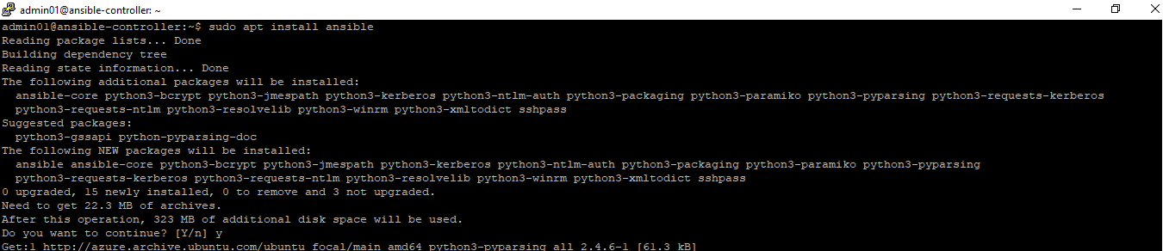

To check the installed ansible version by using the following command:

$ansible --version

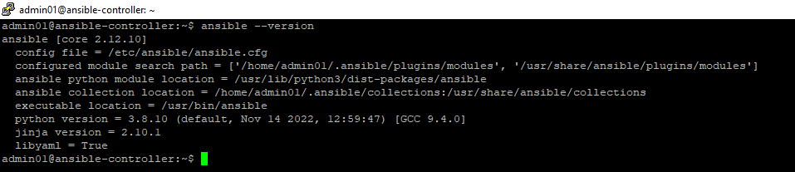

To check the ansible configuration file by using the following the command:

$cat /etc/ansible/ansible.cfg

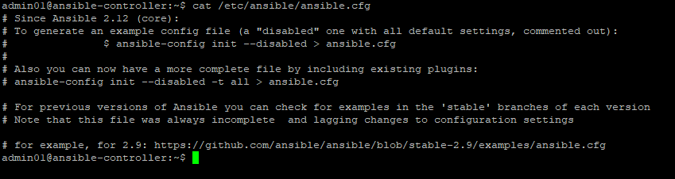

To check the ansible hosts file by using the following command:

$cat /etc/ansible/hosts

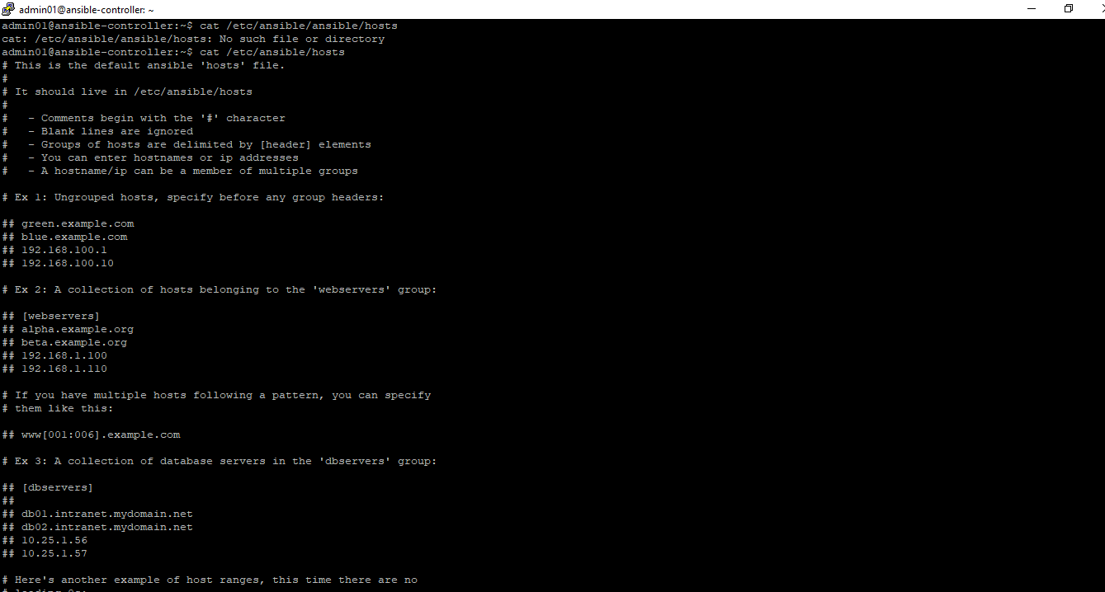

Sudo privilege to host1 user using the following command:

#vi /etc/sudoers



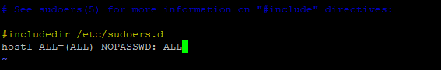

To enabled host1 Password Authentication by using the following command:

#vi /etc/ssh/sshd_config

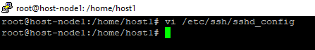

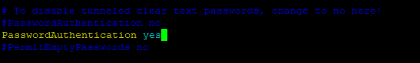

To restart the ssh service by using the following command:

#systemctl restart sshd



To check the all host updates by using the following the command:

#ansible –m ping all



To add host-node1 IP and user id in ansiblecontroller hostfile by using the following the command:

#vi /etc/ansible/hosts



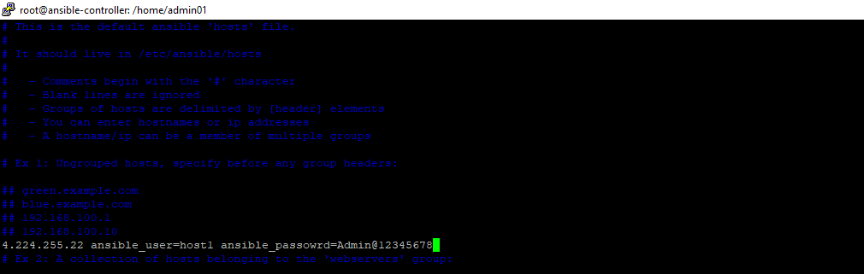

To check the all host updates by using the following the command:

#ansible –m ping all

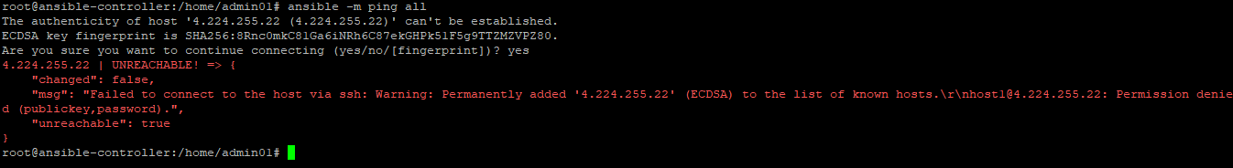

To add host key checking as defaults in ansible configuration file by using the following command:

#vi /etc/ansible/ansible.cfg



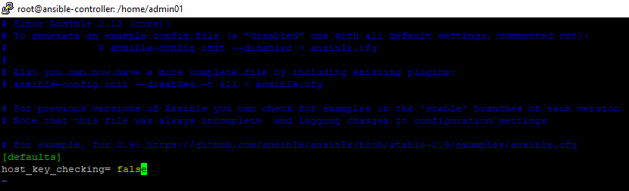

To check the all host updates by using the following the command:

#ansible –m ping all

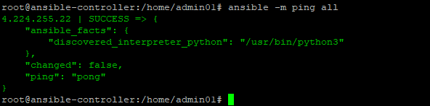

To Ping host-node1 from ansible-controller by using the following command:

#ssh host1@4.224.255.22

